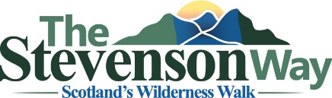
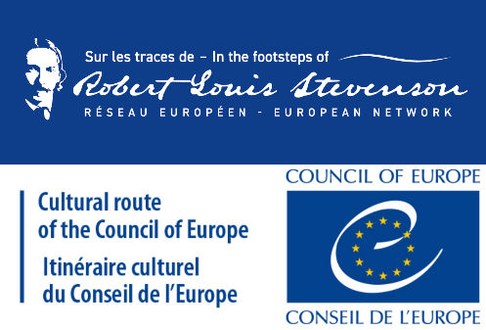
Walk Report

Please use this form to let us know how you got on with your walk. We will never pass your details on to a third party – see our Privacy Policy (www.stevensonway.org.uk/index.php/privacy-policy). We would be delighted to hear from you!
Name:

Email:
Permissions:
Can we use this report on the web site? Yes/No
Can we use photos/videos on the web site? Yes/No
Please contact us (walkreports@stevensonway.org.uk) about photos/videos and we will arrange for a suitable means of transferring them over the web.
What Areas Were Walked:
Mull Yes/No
Morvern Yes/No
Glencoe Yes/No
Rannoch Moor Yes/No
Rannoch to Balquhidder Yes/No
Balquhidder to Edinburgh Yes/No
How Far Did You Walk? Miles/Km
How Many in the Group?
Short Report Summary:

Full Report:

